**MOOC 2-MODULE 5**

[**Supervised Machine Learning: Regression**](https://www.coursera.org/learn/supervised-machine-learning-regression/home/welcome)

### **Further details of regularization**

### Analytical View

### Regularization techniques like L1 (LASSO) and L2 (Ridge) penalties reduce the size of coefficients, leading to simpler models with lower variance.

### Smaller coefficients indicate less impact of features on the outcome variable, while larger coefficients suggest higher sensitivity and variance.

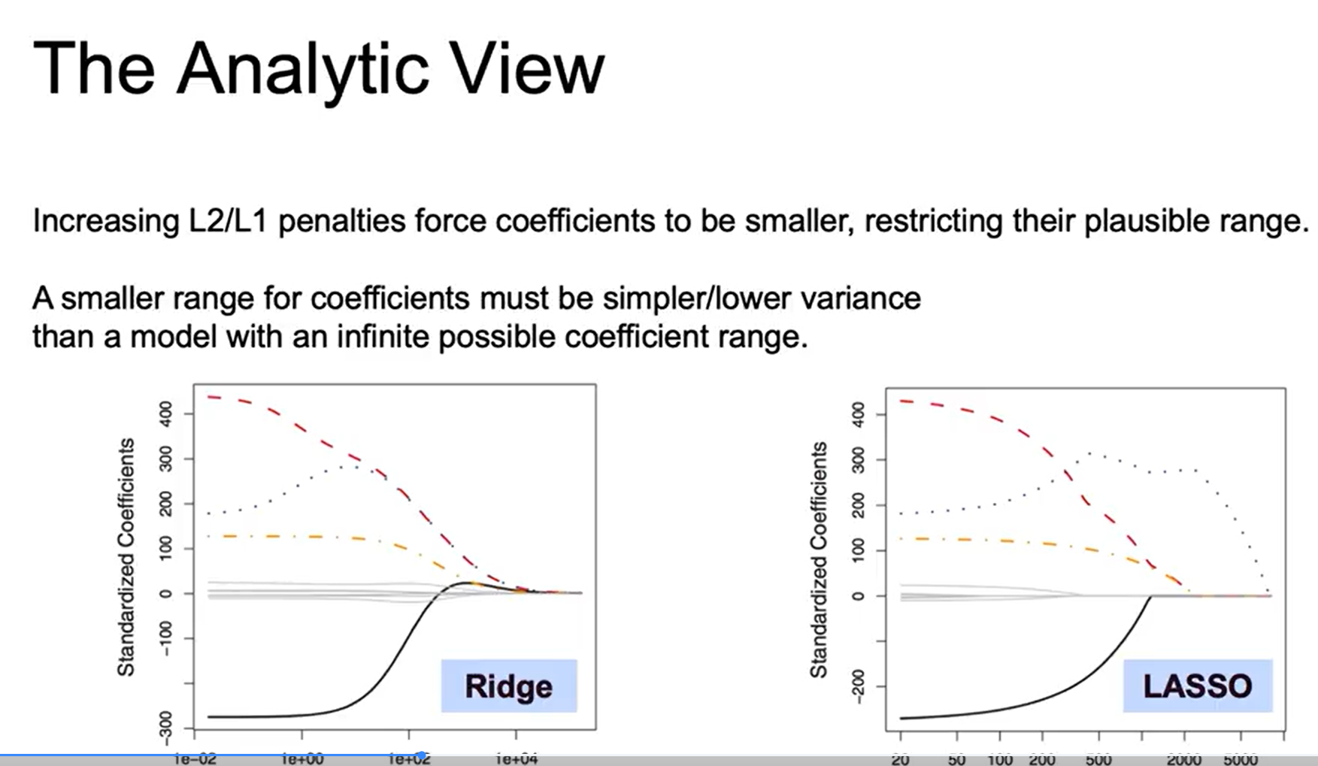

### Geometric View

### Ridge regression minimizes the sum of squared residuals while keeping coefficients small, represented geometrically by a circular constraint.

### LASSO minimizes the absolute values of coefficients, leading to a diamond-shaped constraint that often results in zeroing out some coefficients.

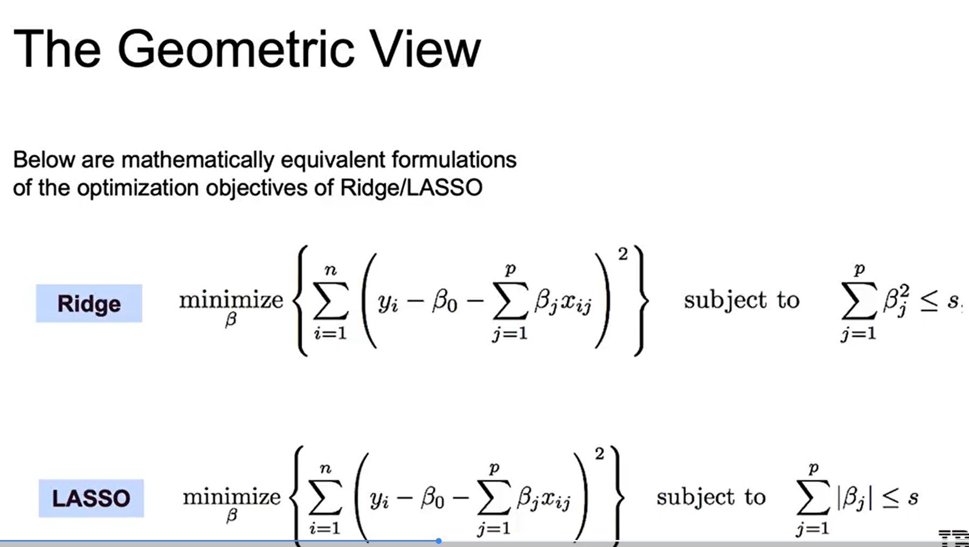

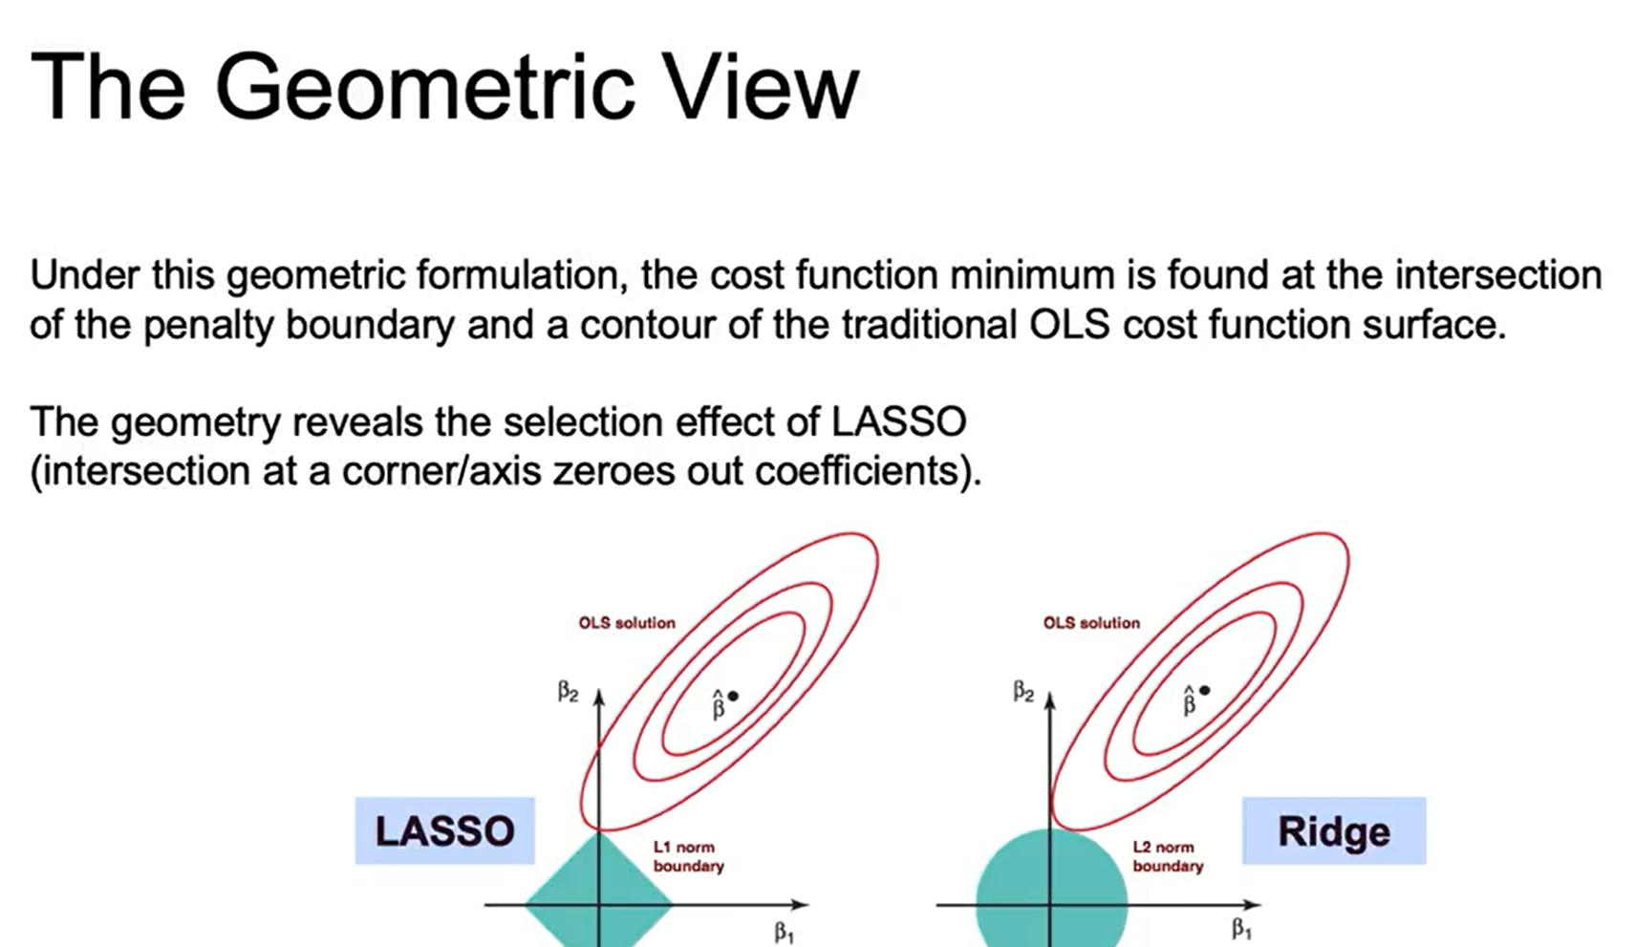

### Probabilistic View

### This perspective recalibrates the understanding of LASSO and Ridge by considering prior distributions for coefficients, enhancing the intuition behind these regularization methods.

### It emphasizes how these methods can be viewed as adjustments to a base problem, providing a deeper understanding of their effects on model complexity.

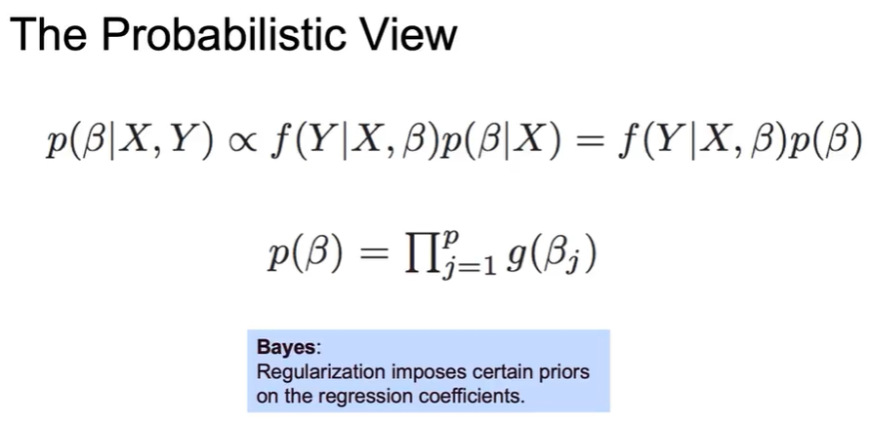

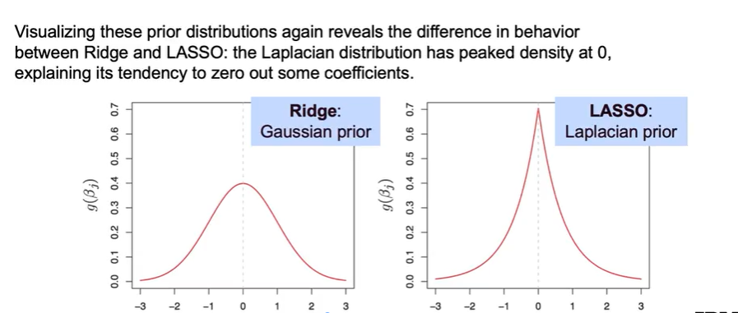

Understanding Regularization

* Regularization imposes prior distributions on regression coefficients to optimize their values based on given data.
* The goal is to find optimal coefficients that minimize error while balancing complexity.

Types of Regularization

* Ridge (L2) regularization uses a Gaussian prior, assuming coefficients are drawn from a normal distribution.
* Lasso (L1) regularization employs a Laplacian prior, which is more likely to zero-out coefficients.

Impact of Regularization

* Regularization increases bias but reduces variance, helping to create a more generalizable model.
* The choice of regularization method affects the model's sensitivity to data changes and its overall complexity.

### 